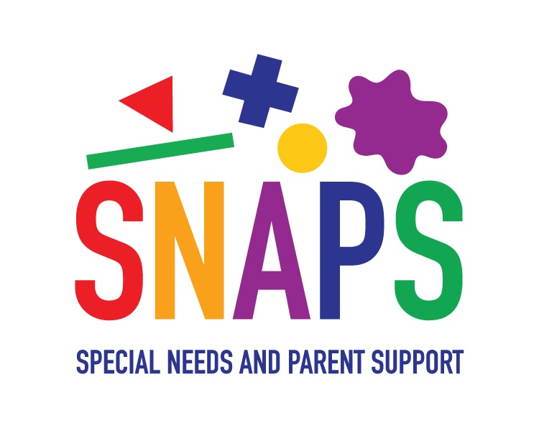

**Job Description**

Job Title: Trusts and Grants Fundraiser

Reporting to: Head of Fundraising

Salary: £28,000 - £30,000 per annum pro rata, dependant on experience

Hours of Work: 22.5 maximum. Flexible Times.

Place of Work: Home Based with travel in Leeds.

Contract: Permanent

The successful candidate will be expected to work as part of the Fundraising team to:

* Raise both restricted and unrestricted income from trusts and foundations, producing high quality, bespoke proposals and reports.
* Develop and deliver a stewardship strategy to build and maintain positive relationships with current trust and grants supporters and encourage future support, ensuring the highest quality of stewardship and cultivation.
* Actively research and engage new supporters. Effectively managing and growing SNAPS’ prospect list of potential funders to approach.
* Produce timely reports, showcasing SNAPS’ impact to funders, ensuring adherence to individual reporting requirements.
* Keep accurate records of projects, amounts raised and donors in line with Data Protection.
* Develop innovative ways to engage with new potential supporters.
* Work with and support donors and fundraisers to ensure their experience of SNAPS is a positive one.
* Thank donors in appropriate and engaging ways to maintain and develop relationships.
* Manage their own budget and meet set financial targets.
* Support across other areas of SNAPS fundraising as required.
* Work sensitively with SNAPS families to engage, but not wear out, their good will.
* Raise awareness of the charity and to highlight its valuable work.
* Attend fundraising meetings when necessary.
* Attend SNAPS’ team meetings when necessary
* Attend SNAPS’ Saturday sessions when necessary.
* Attend Board meetings when necessary.
* Develop good working relationships with the SNAPS’ staff and volunteer team.
* Support additional activities as and when required.
* Adhere to SNAPS’ operational and employment policies and procedures.

To apply please complete and return the SNAPS’ application form by 5pm on 28th November 2023 to Lisa Morton by email [lisa@snapsyorkshire.org](mailto:lisa@snapsyorkshire.org) Interviews will be held on Tuesday 12th December 2022.

More information about SNAPS can be found at [www.snapsyorkshire.org](http://www.snapsyorkshire.org)